R AND POWER-BI PROJECT



Contents

CSV file loaded 3

Library loaded 4

Import Library 5

Missing Values 6

Drop missing values 7

Outliers removed 8

Checking for missing values 9

Removal of outliers in Worldwide Gross 10

Check for outliers using a boxplot 11

Scatter plot 12

Bar chart 13

Dashboard view 14

# CSV file loaded

# Library loaded

# Import Library

# Missing Values

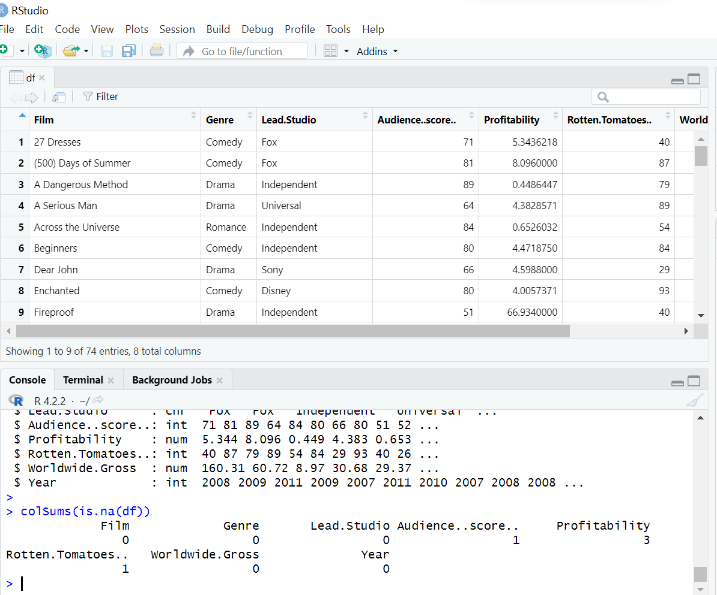

# Drop missing values

# Outliers removed

# Checking for missing values

# Removal of outliers in Worldwide Gross

# Check for outliers using a boxplot

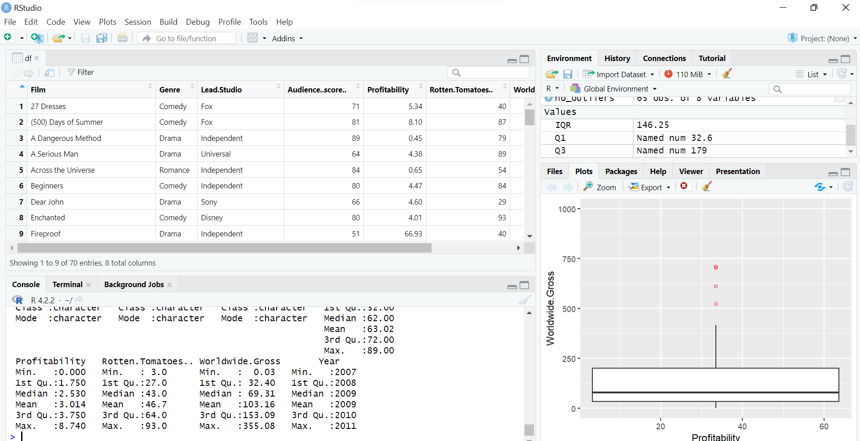

# Scatter plot

# Bar chart

# Dashboard view

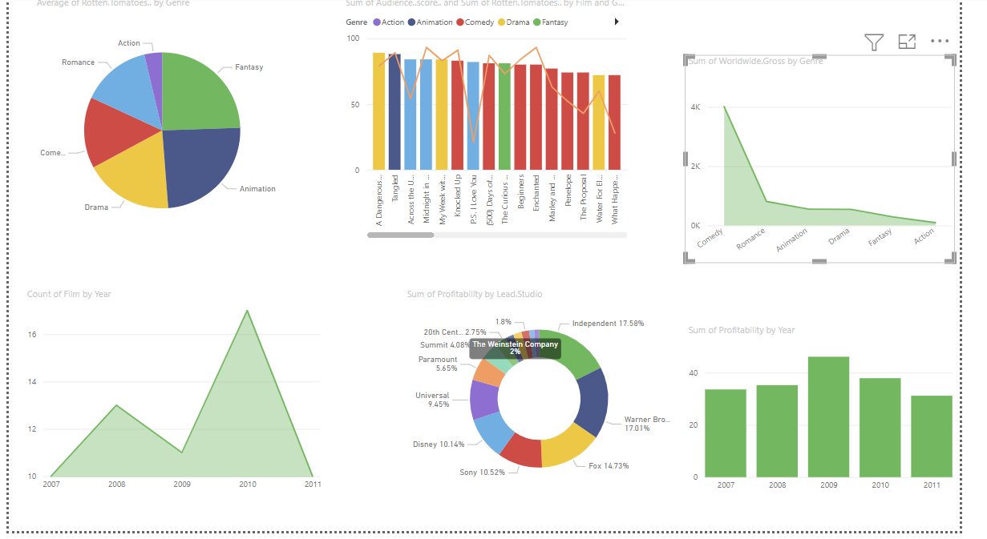

Write.csv(df1, “clean_df.csv)

